17.02.2021

1. Find the name of the employee who, earn more than 15000 but not live in kolkata.

SELECT emp_name,emp_salary FROM `emp` WHERE emp_salary>15000 AND emp_location<>'kolkata';

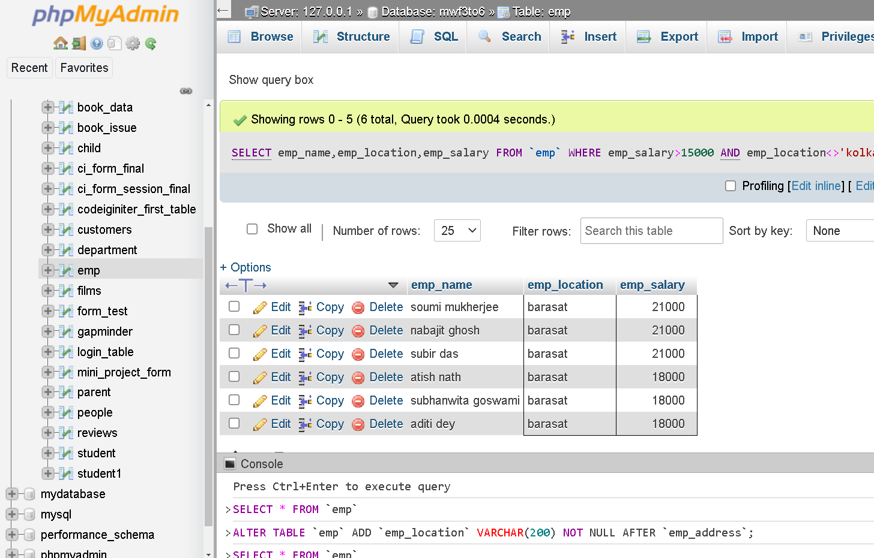

2. Find the head name of all employee.

SELECT emp.emp_name,department.dept_head_name,emp.dept_no

FROM emp

INNER JOIN department

ON emp.dept_no = department.dept_no;

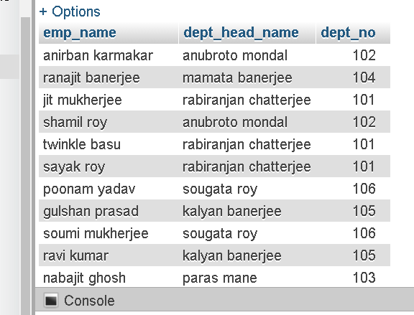

19.02.2021

1. Find the second highest salary from ‘emp’ using subquery.

SELECT MAX(emp_salary) as sec_high_salary FROM `emp`

WHERE emp_salary<>(SELECT MAX(emp_salary) FROM `emp`)

OR

SELECT emp_salary FROM emp ORDER BY emp_salary DESC LIMIT 1 OFFSET 1

Output –

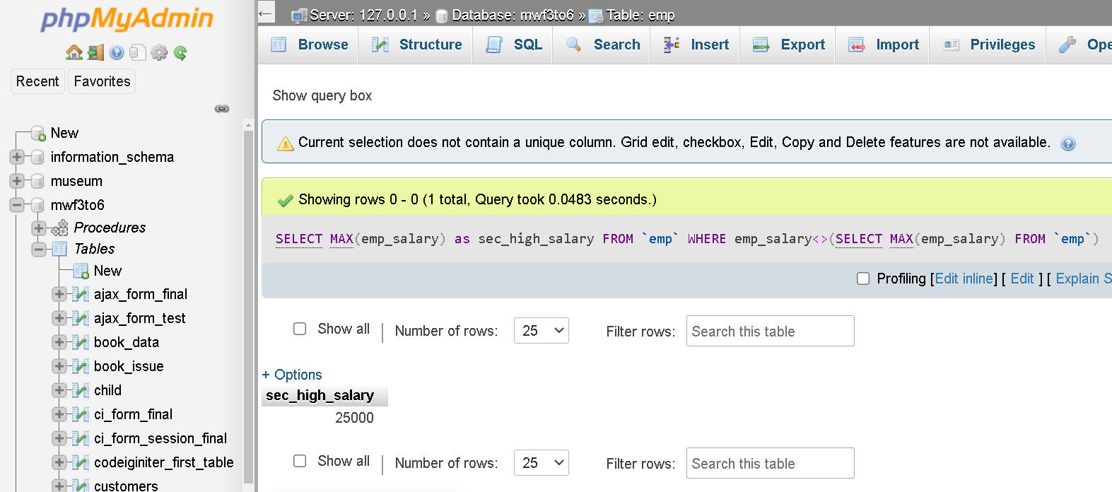

2. Find the name and the address who gets maximum salary in each city.

SELECT emp_name,emp_location,MAX(emp_salary) AS loc_max_sal

FROM `emp`

GROUP BY emp_location

Output –

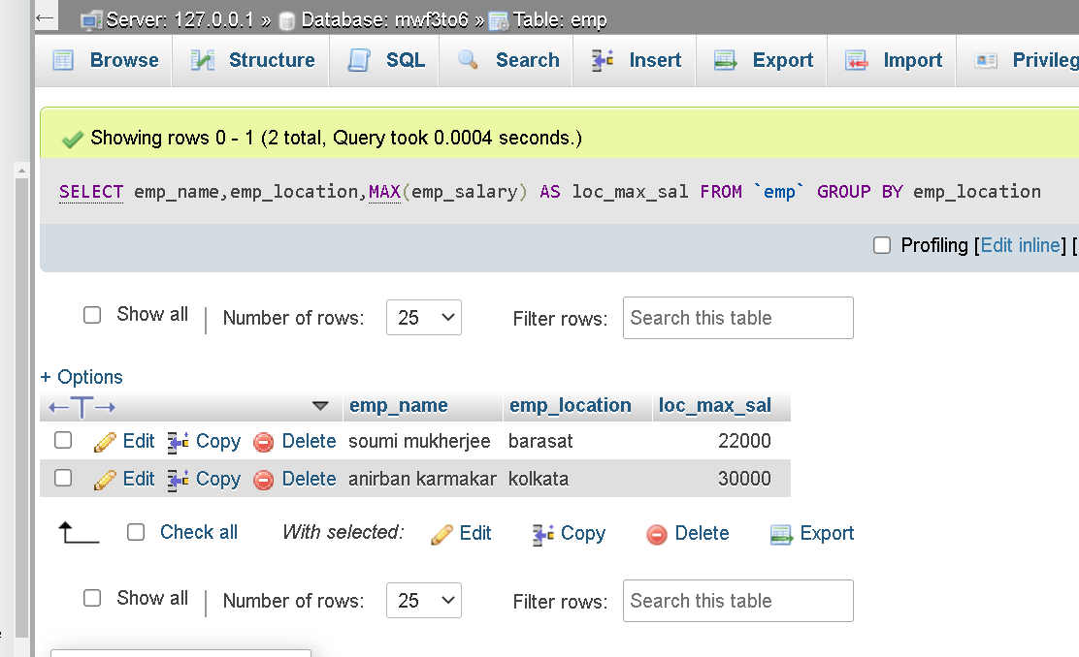

3. Find the employee names who are in the same department

SELECT emp_name,emp_degn,dept_no

FROM `emp`

WHERE dept_no IN(SELECT dept_no

FROM emp

GROUP BY dept_no

HAVING COUNT(dept_no)>1)

ORDER BY dept_no

Output -

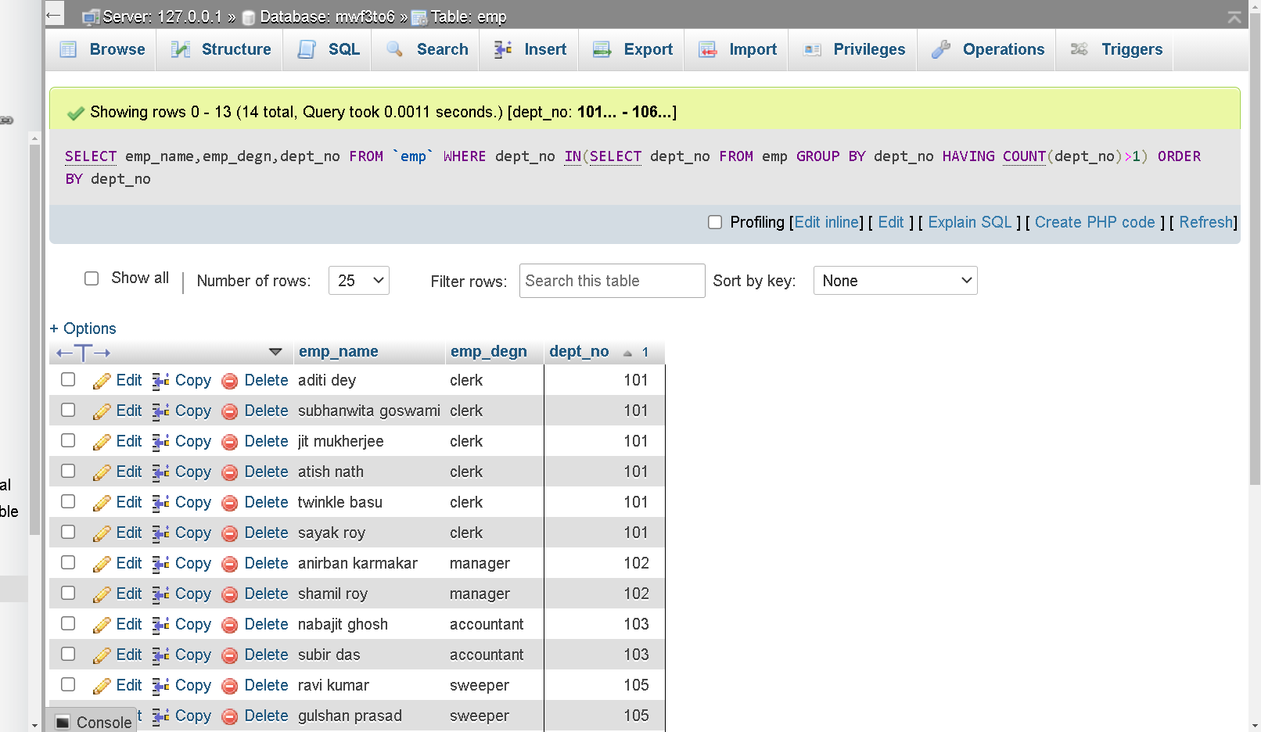

24.02.2021

1. Find the same employee name from your table.

SELECT emp_name FROM emp

WHERE emp_name IN(SELECT emp_name FROM `emp`

WHERE emp_name HAVING COUNT(emp_name>1))

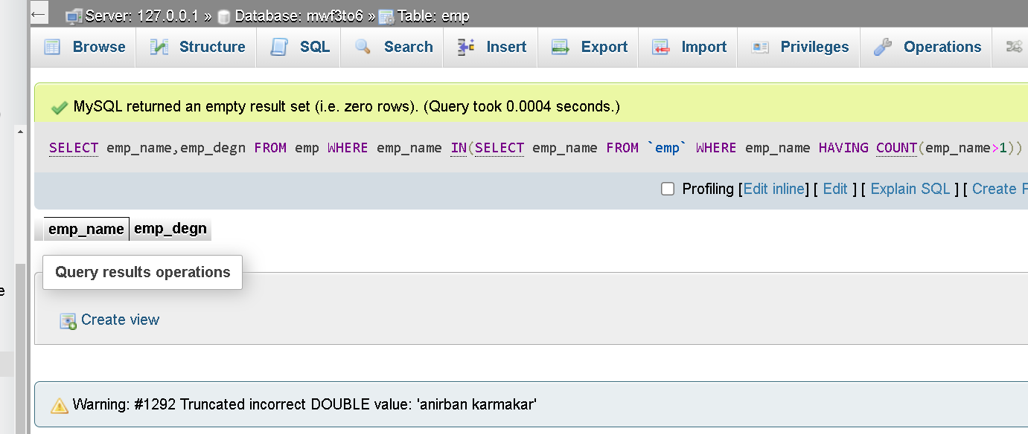

2. Find the employee salary who is in “barasat” and Dept.name is “clerk”.

SELECT emp_name,emp_salary FROM emp

WHERE emp_location="barasat" AND emp_degn="clerk"

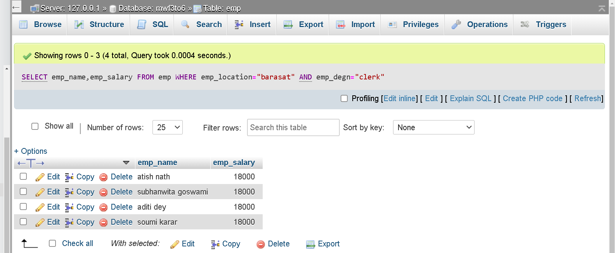

3. Find the dept.no from dept. Table who live in “Mumbai”.